**Characteristics of IoT :-**

* + Connectivity
  + Uniuqe Identity
  + Scalability
  + Dynamic Nature
  + Self Adapting
  + Self Configuring

**Component of IOT:**

* + Control Unit
  + Sensor
  + Communication Modules
  + Power Sources

**IoT Architecture:**

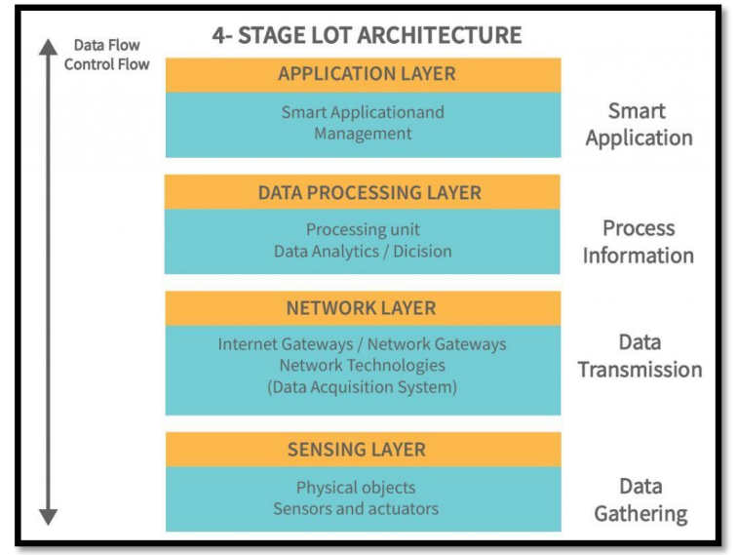

**IoT Protocols:**

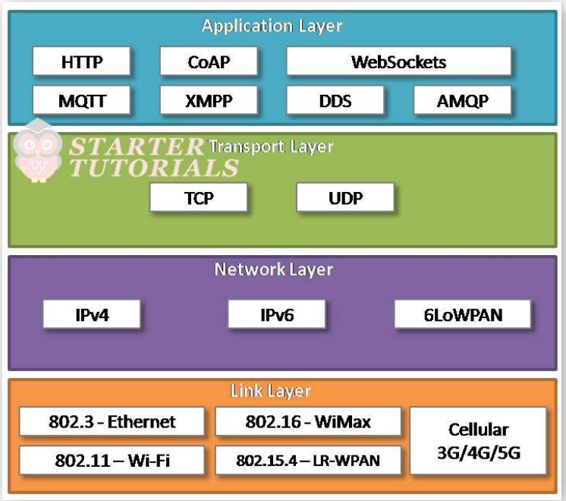

**IoT Functional Block:**

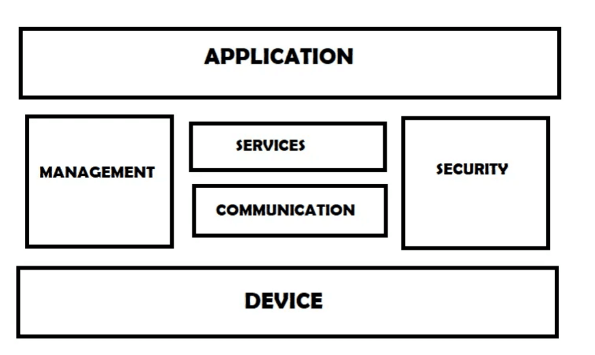

**IoT Communicational Model :**

* + Request-Response Communication Model
  + Publish-Subscribe Communication Model
  + Push-Pull Communication Model
  + Exclusive Pair Communication Model